Accessing Your Analytics
- Go to https://analytics.google.com/analytics/web/
- Sign in with your Google account (does not have to be a Gmail account)

Home Page
- This is the Home Page for Google Analytics, this shows you how many people are on the website at that time and has links to more detailed information.
- The menu highlighted in the yellow box allows you to switch between different “views”
  - Master View – all data from users accessing the website from inside and outside the library.
  - External Traffic – data from users accessing the website from outside the library.
  - Raw Data – a backup of all data from the website.
- The red boxes highlights the links to the Audience Overview page.
- The green box highlights the link to the Behavior Overview page.
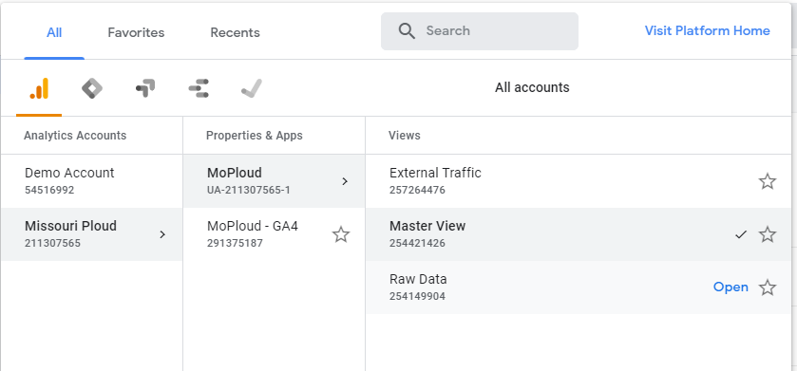
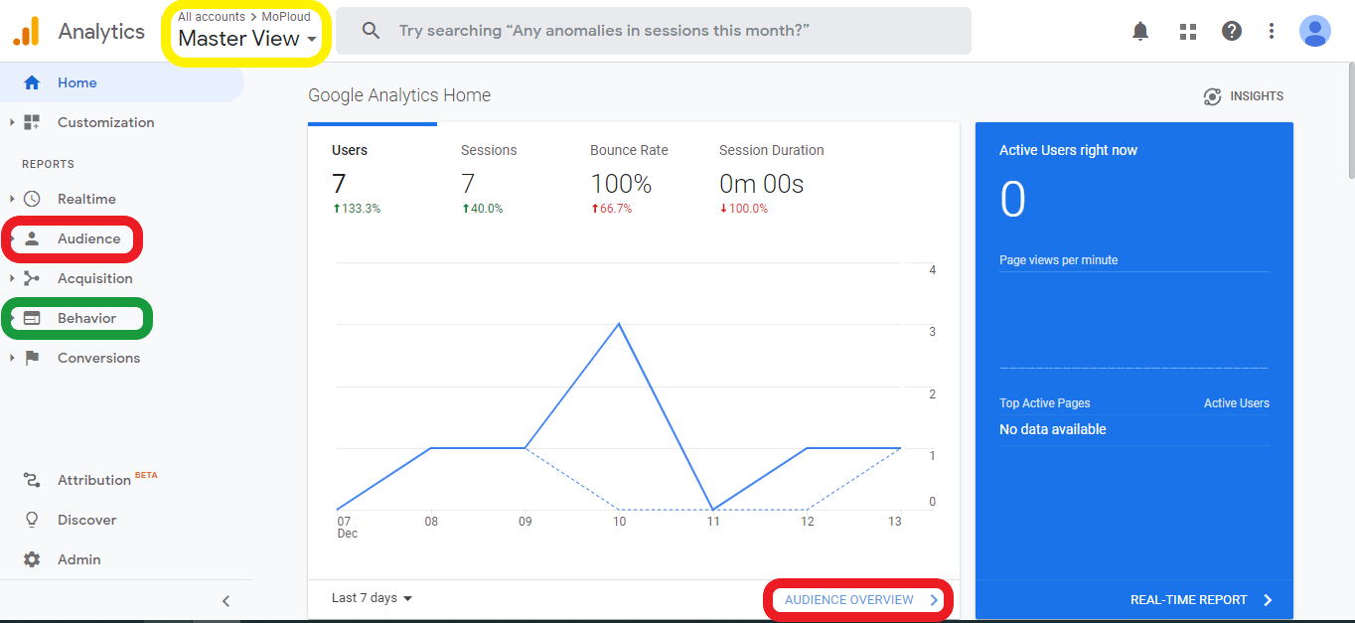

Audience Overview
- The Audience Overview, in red, has information on how many people access your website.
- The yellow box below highlights a drop-down menu that lets you change the date range for the data displayed.
- Each dot on the graph shows you how many people were on the website that day. Simply hover the mouse over a dot (highlighted in purple)
- Below the graph (highlighted in green) shows how many users have accessed the website during the timeframe set above.
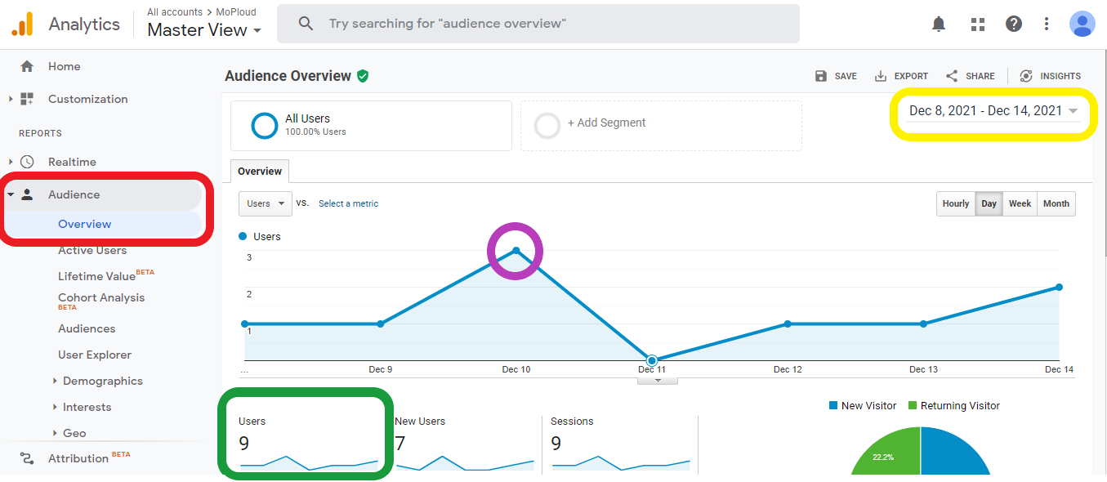

Behavior Overview
- The Behavior Overview, in red, has information on what pages people accessing your website are looking at.
- In the image below, the green box indicates the list of pages that people have accessed and how many times they have been viewed.
  - The “/” page is your homepage.
